SQL Assignment 3 (KRUTHIKA K J)

Table 1: Employees
EmployeeID | FirstName | LastName | DepartmentID | HireDate | Salary
101 | Alice | Johnson | 1 | 2022-01-15 | 75000
102 | Bob | Smith | 2 | 2021-06-20 | 62000
103 | Charlie | Davis | 1 | 2023-03-10 | 58000
104 | Diana | Prince | 3 | 2020-11-05 | 90000
105 | Ethan | Hunt | 2 | 2022-08-25 | 64000

Table 2: Departments
DepartmentID | DeptName | Location
1 | Engineering | New York
2 | Marketing | Chicago
3 | Executive | San Francisco
4 | Sales | Austin

Table 3: Projects
ProjectID | ProjectName | LeadEmployeeID | Budget | Status
501 | Alpha Tech | 101 | 150000 | Active
502 | Beta Cloud | 104 | 300000 | Active
503 | Gamma SEO | 102 | 50000 | Completed
504 | Delta Mobile | 101 | 80000 | Pending

Problems
- List all columns for all employees in the 'Engineering' department (DepartmentID = 1).
select * from employees where DepartmentID=1
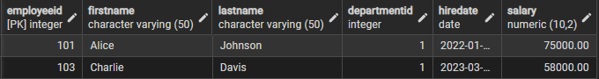

- Find the names of all departments located in 'Chicago'.
select * from departments where location='Chicago'


- Show the total number of projects currently marked as 'Active'.
select count(*) as active_status from Projects
where status= 'Active';


- List the unique last names of all employees, sorted alphabetically.
select distinct lastname from employees order by lastname asc;
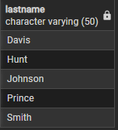

- Retrieve the FirstName and LastName of employees who earn more than $65,000 and were hired after January 1st, 2021.
select CONCAT(firstname, ' ', lastname) AS full_name from employees where salary>65000
and HireDate>'2021-01-01'


- Calculate the average salary for each department; display the DepartmentID and the average salary.
select DepartmentID, avg(salary) as avg_salry from employees
group by DepartmentID
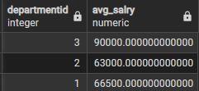

- List the ProjectName and the lead employee's FirstName by joining the Projects and Employees tables.
select p.projectname,e.firstname from projects p join employees e
on p.LeadEmployeeID=e.EmployeeID


- Find all employees who are not currently leading any project.
select EmployeeID,FirstName from employees where
employeeid not in(select LeadEmployeeID from projects)


- Show the names of departments that have no employees assigned to them.
select departmentID,deptName from departments where
departmentid not in(select DepartmentID from employees)


- Find the employee(s) with the highest salary and display their full name and salary amount.
select CONCAT(firstname, ' ', lastname) AS full_name,salary from employees
group by full_name,salary
order by salary desc limit 1;


- Calculate the total budget for all projects led by employees in the 'Engineering' department.
Select sum(p.budget),
select sum(p.Budget) AS Total_budget ,e.DepartmentID from Projects p join Employeese
ON p.LeadEmployeeID = e.EmployeeID join Departments d ON e.DepartmentID =d.DepartmentID where d.DeptName = 'Engineering'
group by e.DepartmentID;


- List all departments that have more than one employee, along with the count of employees in each.
select d.DeptName, COUNT(e.EmployeeID) AS EmployeeCount from Departments d
join Employees e ON d.DepartmentID = e.DepartmentID group by d.DeptName having count(e.EmployeeID) > 1;
